JOB MANAGEMENT MODULE: DESIGN & SPECIFICATION

1. INTRODUCTION
1.1 Purpose of this Document
The purpose of this document is to describe the design of the Job Management module. It explains how the system manages job creation, task execution, workflow processing in a manufacturing environment.
1.2 Scope of this Document
This document covers the working of the Job Management module, including job lifecycle, task scheduling, execution tracking, and dependency handling. It also describes interaction with Order and Inventory modules to ensure efficient production and timely completion.

2. SYSTEM OVERVIEW
2.1 Role of Job Management in Overall System
The Job Management module acts as the core execution unit of the system. It converts confirmed customer orders into manufacturing jobs and manages the complete production workflow, including task execution, scheduling.
2.2 Interaction with OMS (Order Management System)
The Job Management module receives confirmed order details such as product type, quantity, and deadline from the Order Management System. Based on this information, it creates jobs and updates the order status after job completion.
2.3 Interaction with Inventory System
The module interacts with the Inventory System to check material availability and allocate required resources for production. It also updates inventory usage during manufacturing.
2.4 User Roles (Production Staff, Job Manager) //MATCH BTW 3 SYSTEMS
- Job Manager: Oversees job progress, scheduling, and ensures timely completion
- Production Staff: Executes assigned tasks and updates task status

3. FUNCTIONAL REQUIREMENTS
- Job Creation
The system allows creation of a job based on confirmed order details. A unique Job ID is generated, and information such as product name, quantity, and deadline is stored in the system.
- Job Assignment
The system assigns tasks to workers or machines based on the defined process steps. Each task is linked to a specific part and operation.
- Job Scheduling
The system schedules tasks based on job deadlines and resource availability. It ensures proper sequencing of operations and supports parallel execution of independent tasks.
- Job Tracking and Status Updates
The system tracks the progress of jobs and tasks using status indicators such as Pending, In Progress, and Completed. Users can view real-time updates of job execution.
- Job Completion
A job is marked as completed only after all tasks are finished and the final product passes quality checks. The system then updates the job status accordingly.
- Job Modification and Cancellation
The system allows modification or cancellation of jobs before execution begins. Changes may include updating quantity, deadline, or job details.
- Notifications and Alerts
The system generates notifications for important events such as job creation, task assignment, delays, and job completion to keep users informed.

4. NON-FUNCTIONAL REQUIREMENTS
- Performance
The system should support up to 10 concurrent users, mainly consisting of Production Staff and at most 1–2 Job Managers, without delay.
The system should handle up to 100 jobs per day efficiently.

- Security
The system should provide login-based authentication for Job Manager and Production Staff. Role-based access control should ensure:
- Only Job Managers can create and assign jobs
- Only Production Staff can update assigned jobs
The system should allow maximum 3 failed login attempts, after which access is blocked for 2 minutes.

- Reliability
The system should ensure no data inconsistency, meaning:
- No duplicate job entries
- No loss of job status updates
The system should be able to recover from minor failures without affecting ongoing job data.

- Usability
Job status updates should be simple and require minimal user input (e.g., status selection and submit). The system should provide clear and meaningful error messages to guide users.
The interface should be user-friendly and easy to understand, allowing users to perform tasks like job creation, tracking, and updates without complexity.

- Scalability
The system should support future expansion up to 30–50 users.
The system should handle up to 300–500 jobs per month with improvements.
The system design should allow adding new modules (e.g., inventory or reporting) without major changes.

5. WORKFLOW OF JOB MANAGEMENT
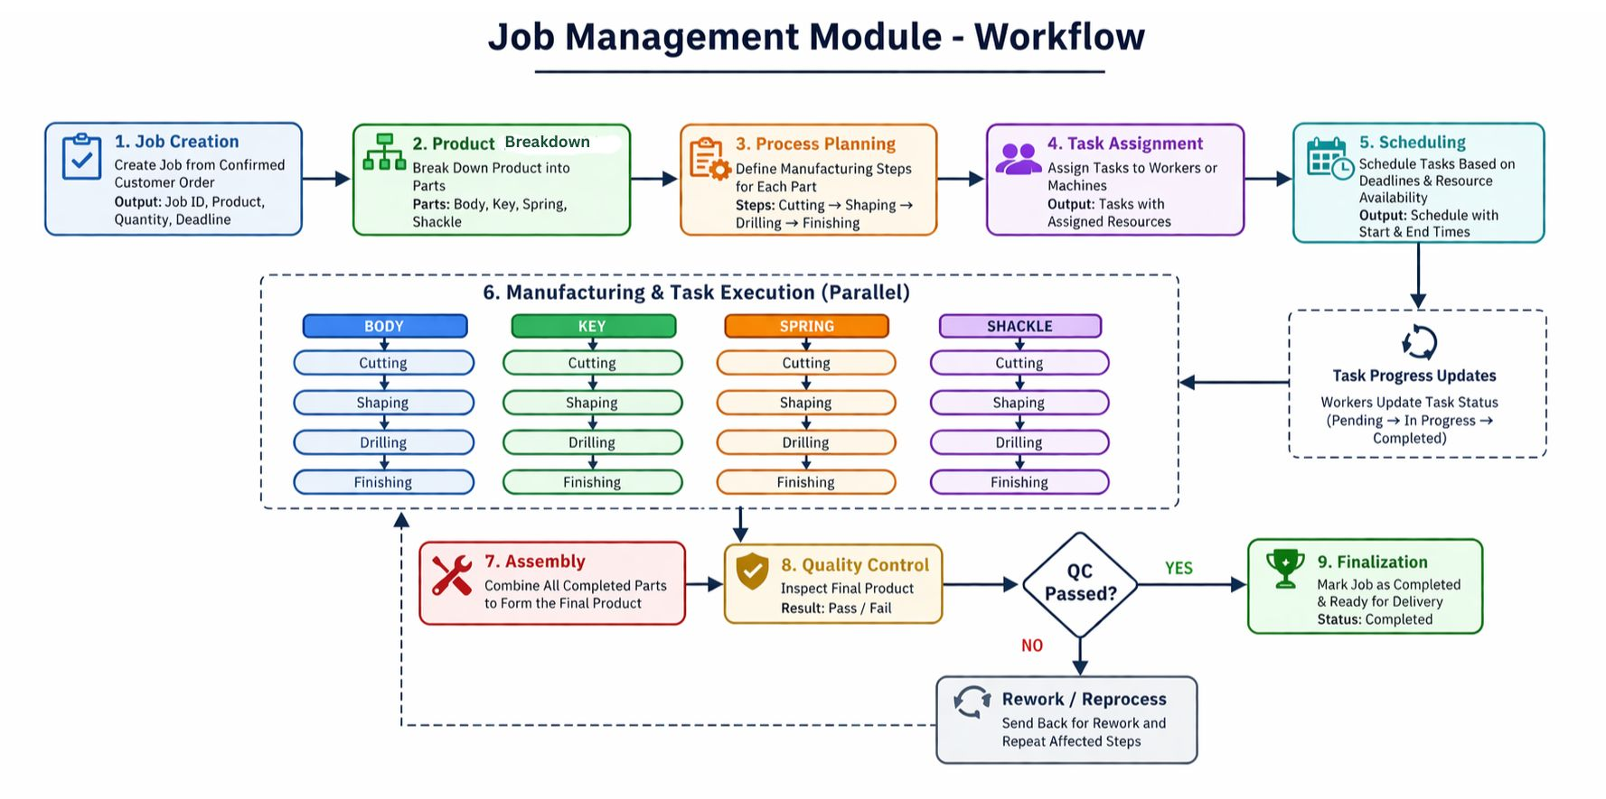

5.1 Job Creation Flow
- The system receives confirmed order details
- A new job is created with a unique Job ID
- Product details such as name, quantity, and deadline are stored
- The product is broken down into required parts
5.2 Job Execution Flow
- Each part is assigned a sequence of processes (Cutting, Shaping, Drilling, Finishing)
- Tasks are generated for each process step
- Tasks are assigned to workers or machines
- Multiple parts are processed in parallel
- The system tracks task status (Pending → In Progress → Completed)
5.3 Job Completion Flow
- After all parts are completed, assembly is performed
- The final product undergoes quality inspection
- If the product passes, the job is marked as completed
- If it fails, the job is sent for rework
- Final status is updated as ready for delivery

6. INTERFACE DESIGN
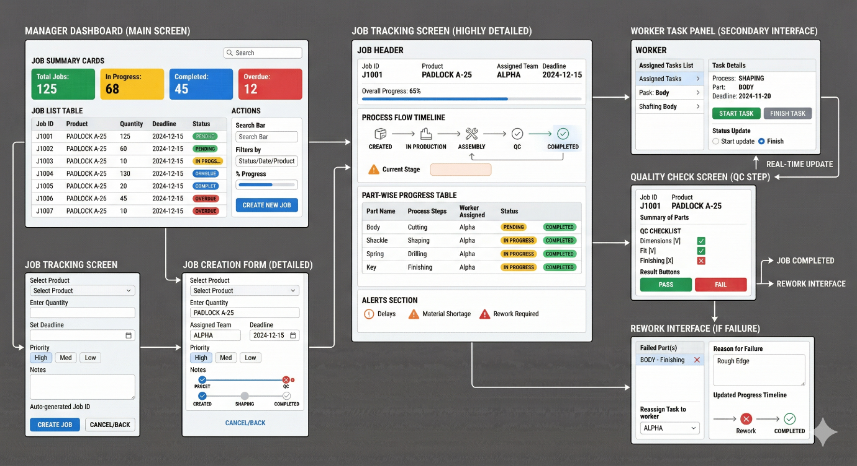
JOB MANAGER DASHBOARD (MAIN SCREEN)
6.1 User Interface Description
The Job Management module provides the following key interfaces:
- Job Manager Dashboard: Displays job summary cards, job list table, filters, and Create Job button.
- Job Creation Form: Allows entering product, quantity, deadline, priority, and shows auto-generated Job ID.
- Job Tracking Screen: Shows overall progress, process timeline, part-wise progress, and alerts (delay, rework).
- Worker Task Panel: Shows assigned tasks and allows Start/Finish updates.
- Quality Check Screen: Displays QC checklist and Pass/Fail buttons.
- Rework Interface: Shows failed parts, reason for failure, and reassignment options.
6.2 Input and Output Details
Inputs
- Product name, quantity, deadline, priority
- Worker task updates (Start/Finish)
- Part status updates
- QC checklist values and Pass/Fail decision
- Rework details (reason, reassigned worker)
Outputs
- Job ID and job details
- Job and task status updates
- Overall and part-wise progress
- Alerts: delays, material shortages, rework required
- Final QC result and job completion status

6.3 External System Interfaces
Order Management System (OMS)
- Input: Confirmed order details
- Output: Job completion status and delay updates
Inventory System
- Input: Material availability information
- Output: Material usage updates and shortage alerts

7. SYSTEM ARCHITECTURE
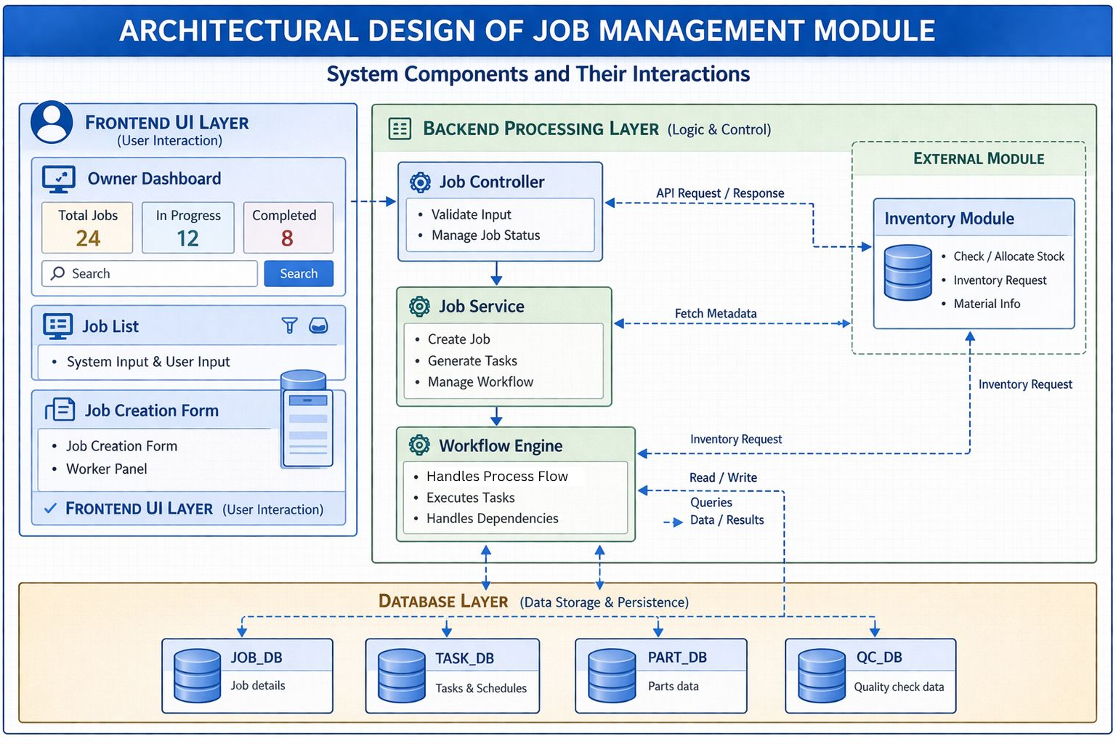
Job Manager Dashboard
7.1 Architectural Overview
The Job Management module follows a layered architecture consisting of frontend, backend, workflow engine, and database layers. The system uses a request-response model where user actions are processed by the backend and stored in the database, while the workflow engine manages task execution and dependencies.
7.2 Components of Job Management Module
- Frontend Layer:
User interfaces such as Owner Dashboard, Job Creation Form, and Worker Panel
- Backend Layer:
Job Controller and Job Service for handling job logic and processing
- Workflow Engine:
Manages task sequencing, parallel processing, and dependency handling
- Database Layer:
Stores job, task, schedule, and quality check data
7.3 Interaction with Other Modules
- Order Management System (OMS):
Sends confirmed order details for job creation and receives job completion updates
- Inventory System:
Provides material availability and updates stock during production

8. DETAILED DESIGN
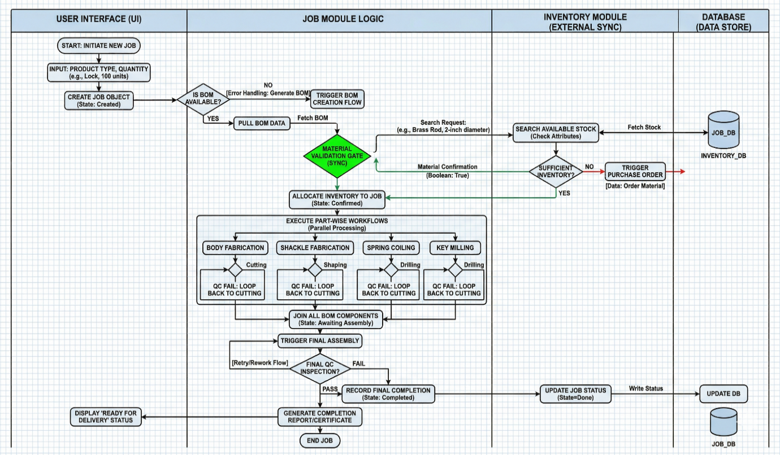

8.1 Detailed Workflow Description
The workflow begins with job creation where the user inputs product type and quantity. The system creates a job object and checks for BOM (Bill of Materials) availability. If not available, it triggers BOM creation.
Once BOM data is fetched, the system validates material availability through the inventory module. After confirmation, inventory is allocated to the job.
The system then executes part-wise workflows in parallel, including body fabrication, shackle fabrication, spring coiling, and key milling. Each part undergoes multiple processes such as cutting, shaping, and drilling. In case of quality failure at any stage, the process loops back for rework.
After all parts are completed, they are assembled, followed by final quality inspection. If the product passes, the job is marked as completed and ready for delivery.

8.2 Data Flow Explanation
- User inputs job details through the interface
- Job data is sent to the backend and stored in the database
- BOM data is fetched from product database
- Inventory module provides material availability status
- Task and process data flow through the workflow engine
- Final job status is updated in the database

8.3 Process Breakdown
- Job Initialization: Job creation and BOM validation
- Material Validation: Checking and allocating inventory
- Task Execution: Parallel processing of parts
- Rework Handling: Loop-back mechanism for QC failures
- Assembly Process: Combining all manufactured parts
- Quality Check: Final inspection (Pass/Fail)
- Completion: Update job status and generate output

9. DATA ENTITIES AND ATTRIBUTES

9.1 Job Entity Attributes
The system uses the following key entities and their attributes:
- Job: JobID, ProductName, Quantity, Deadline, Status
- Task: TaskID, JobID, TaskName, Status, AssignedTo
- Part: PartID, JobID, PartName, Status
- Quality Check: QC_ID, JobID, Result

